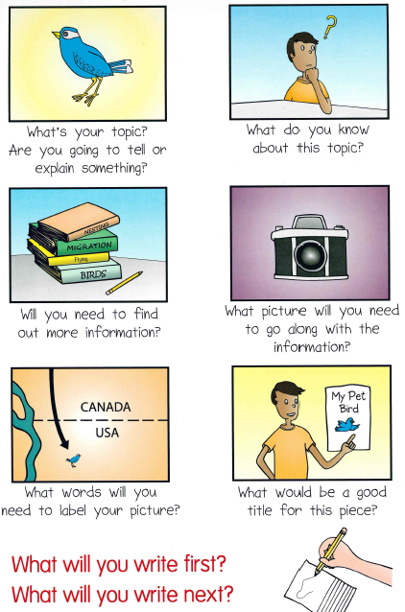

! ? .

1st,2nd,3rd

details

Aa